Tuesday 29th September 2020

RE.: Remaining Safe in School – From Warwickshire County Council
Dear Parent,
We are so pleased we have been able to welcome our children back into school; it is a really important step that we need to take for their education, including their mental and physical wellbeing. I appreciate the new school year will raise some concerns among you as to what will happen should a positive case arise in school.
Please remember and reassure your child that, for most people, coronavirus should be a mild illness. But we all need to remain vigilant by watching out for symptoms.
I hope the information below will help you to understand the process and steps we need to follow and to see how closely we are all working together to keep the risk related to reopening our schools to all year groups, to a minimum, whilst also keeping children safe in school.
Process and Steps
Avoiding symptoms in school and getting tested if you are unwell
We need to prevent Coronavirus coming to school. You should self-isolate if:
- You share a house with someone with coronavirus symptoms (see chart below).
- You are experiencing any coronavirus symptoms (see chart below)
- You tested positive for coronavirus and are within the 10 day isolation period
- Your child has been advised by the NHS test and trace service to self-isolate or aware your child is a close contact of someone who has tested positive for coronavirus (isolate for 14 days from last contact). Household members not in contact with a person who was positive for Coronavirus do not need to isolate.
- You have returned from abroad and government guidance states you or your child need to quarantine for 14 days (household members who haven’t travelled do not need to isolate)

Anyone with coronavirus symptoms should test negative before your child returns to school.
If your child or anyone in the household is showing coronavirus symptoms, do not come to school and book a test immediately. While you wait for the test results your household should remain at home and self-isolate. The link below provides further information.
https://www.gov.uk/government/publications/covid-19-stay-at-home-guidance/stay-at-home-guidance-for-households-with-possible-coronavirus-covid-19-infection
Those with symptoms will be able to book a test if they are within 5 days of symptoms, after that time the test isn’t effective. If you’re not sure it could be coronavirus, get a test. Unfortunately, the 119 service has been making mistakes recently, and refusing those eligible, if you have had the below symptoms within 5 days you can get tested:
- you have had a high temperature
- you have a new, continuous cough or worsening of a cough you already had
- you’ve lost your sense of smell or taste or it’s changed
https://www.nhs.uk/conditions/coronavirus-covid-19/symptoms/
If your child is positive inform the school immediately, we need the test result, positive or negative to enable us assure our community that we are doing all we can to prevent the opportunity for spread of Coronavirus in the school.

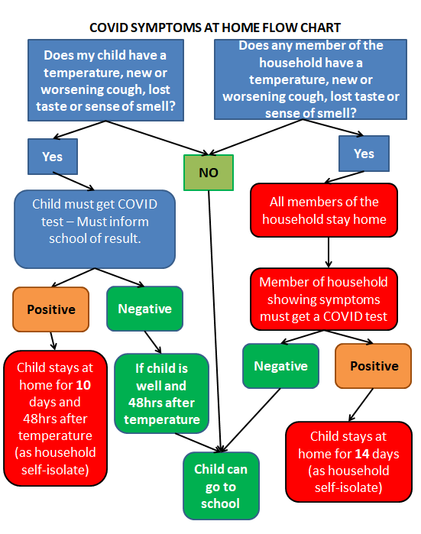

Booking a Test
You can book a test online at https://www.gov.uk/get-coronavirus-test
Testing slots are refreshed throughout the day but the best time to book a test is after 8pm, sometimes trying postcodes of different Local Authorities can come up with additional local test centres. If you are unable to test within the 5 day window from symptoms starting, you must remain off school for the full 10 days – as we would not know if you were negative. In addition siblings must remain off school for 14 days as close contacts
Please do not book a home test unless you have no form of transport to get to a test centre, as the results of these can take a long time to come back, you must find your priority post box to return these. Please read the information in the link below.
https://www.royalmail.com/priority-postboxes

Preventing transmission in and around our school
Please wear face coverings when dropping off and collecting your children.
We know face coverings are one of the many tools which have been recommended as a mitigating factor when people are not able to maintain 2 metre social distancing. Currently they are mandated for indoors (for those that can safely wear them). We have found that many people who need to collect their children are experiencing that other parents are not following the 2 metre rule and encroaching on their space.
Children and adults who have underlying health conditions need to attend school and cannot protect themselves against other parents not maintaining safe social distancing. We must do everything we can to prevent transmission and protect those who are most vulnerable. In addition, we know that adults are more likely to transmit the virus than children; therefore adult to adult transmission is a real concern and could impact on the environment inside of school. However, we will continue to promote social distancing messages because 2m distancing is still the best action we can take. Due to the complaints we have had from parents, we need to put in mitigating factors to account for these interactions and prevent transmission of the virus.

What happens when there has been a positive case in School?
- As soon as we are informed of a person who tests positive for Coronavirus, we immediately identify all close contacts and inform them not to come to school/ send them home to self-isolate for 14days. This prevents the virus from spreading in school. Household member of close contacts do not need to self-isolate unless they develop symptoms.
- On some occasions we may send home all possible close contacts as we review the situation and welcome children back who haven’t been a close contact.
- The school works with the DfE, PHE and with the Public Health team at Warwickshire County Council for the best advice on next steps.
Who is considered a close contact in a school setting?
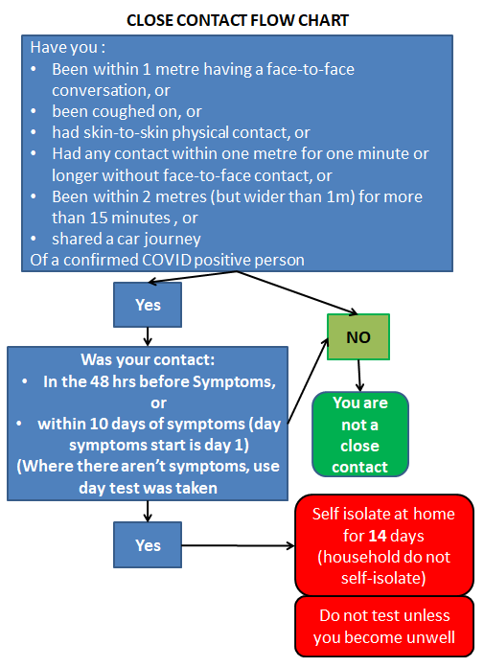

If a close contact becomes unwell whilst self-isolating
If a close contact becomes unwell, within the 14-day period, as a close contact with a confirmed positive it is possible you may have Coronavirus. Please book a test online. Your household are to self-isolate until the test result.

If the test is negative the household can return to their usual activity but the close contact must continue to isolate for the full 14 days.

If the test is positive you then need to isolate for 10 days from the start of symptoms and your household become close contacts and must isolate for 14 days.

I hope this letter addresses some of your questions. Please talk to us at school if you have any further concerns.
Very best wishes,
Anne Clewley, Head Teacher

